**Subquery Vs CTE:**

Subqueries can be useful for simpler tasks but nested subqueries can be complex.

In that case CTE can be useful.

If we use subqueries there might be situation where we need to write the same query/logic again and again.

Instead of **repeating the same subquery logic** again and again, you:

1. Write that logic **once** inside a CTE
2. Give it a name (like a temporary table)
3. Then just **call the name** wherever you need it in the main query.

Example:

Without CTE:

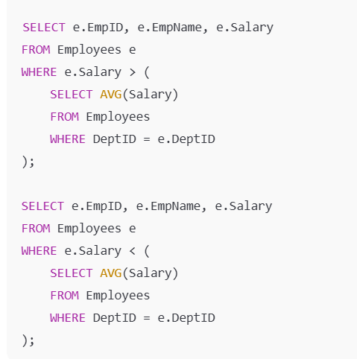

With CTE:

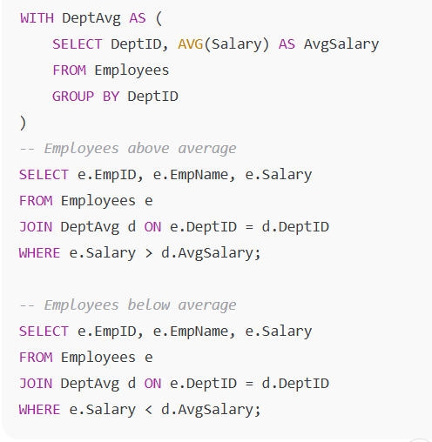

Here DeptAvg is a cte which is reference twice and can be refer multiple times in the main query.